35.46: a) The electric field is the sum of the two wave functions, and can be written:
b) 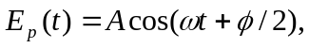 so comparing with part (a), we see that the amplitude of the wave (which is always positive) must be 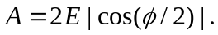
c) To have an interference maximum, 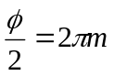. So, for example, using 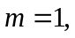the relative phases are 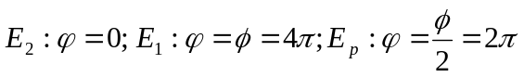, and all waves are in phase.
d) To have an interference minimum, 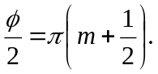So, for example using 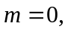relative phases are and the resulting wave is out of phase by a quarter of a cycle from both of the original waves.
e) The instantaneous magnitude of the Poynting vector is:
For a time average, 